Name: Ningyuan Zhang

Section: A

Date: 4/29/2017

Instructor: Akhilesh Tyagi

Lab-8

**Part 1.**

1. Miss Rates (Data Cache)

|  |  |  |  |  |
| --- | --- | --- | --- | --- |
| #Set\Associativity | 1-way | 2-way | 4-way | 8-way |
| 16 sets | 0.1209 | 0.1126 | 0.1097 | 0.1093 |
| 32 sets | 0.1152 | 0.1107 | 0.1094 | 0.1093 |
| 64 sets | 0.1132 | 0.1095 | 0.1093 | 0.1093 |
| 128 sets | 0.1110 | 0.1093 | 0.1093 | 0.1093 |
| 256 sets | 0.1103 | 0.1093 | 0.1093 | 0.1093 |

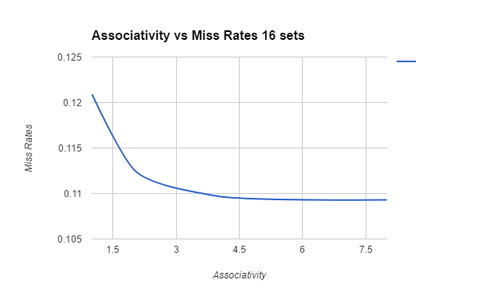

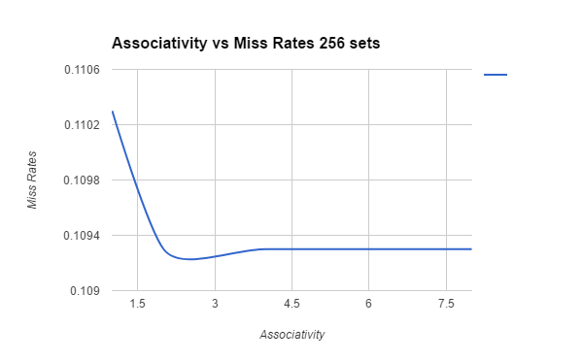

1. Miss Rates (Instruction Cache)

|  |  |  |  |  |
| --- | --- | --- | --- | --- |
| #Set\Associativity | 1-way | 2-way | 4-way | 8-way |
| 16 sets | 0.0435 | 0.0262 | 0.0171 | 0.0148 |
| 32 sets | 0.0036 | 0.0204 | 0.0151 | 0.0100 |
| 64 sets | 0.0203 | 0.0144 | 0.0097 | 0.0016 |
| 128 sets | 0.0165 | 0.0097 | 0.0019 | 0.0003 |
| 256 sets | 0.0095 | 0.0031 | 0.0003 | 0.0003 |

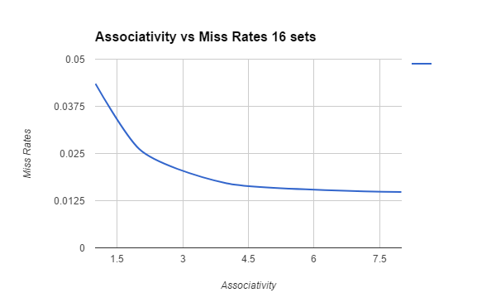

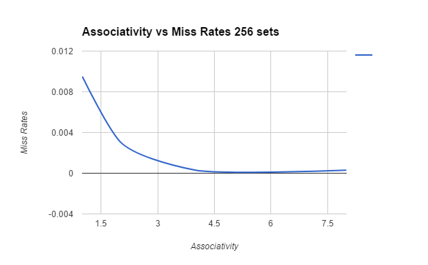

**Part 2.**

1. dll 0.0061 miss rate
2. dll 0.0329 miss rate

**Part 3.**

Cache Size

|  |  |  |  |  |
| --- | --- | --- | --- | --- |
| #Set\Associativity | 1-way | 2-way | 4-way | 8-way |
| 128 sets | 4096 | 8192 | 16384 | 32768 |
| 256 sets | 8192 | 16384 | 32768 | 65536 |
| 512 sets | 16384 | 32768 | 65536 | 131072 |
| 1042 sets | 32768 | 65536 | 131072 | 262144 |

Read Energy (nJ)

|  |  |  |  |  |
| --- | --- | --- | --- | --- |
| #Set\Associativity | 1-way | 2-way | 4-way | 8-way |
| 128 sets | 0.00572275 | 0.00887587 | 0.0170783 | 0.0395039 |
| 256 sets | 0.00681765 | 0.0101105 | 0.018893 | 0.0423044 |
| 512 sets | 0.00849918 | 0.0125291 | 0.0223248 | 0.0395966 |
| 1042 sets | 0.0121715 | 0.0179733 | 0.0287393 | 0.0464375 |

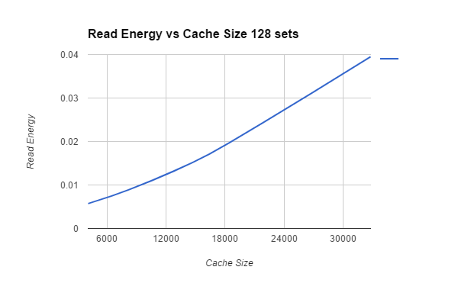

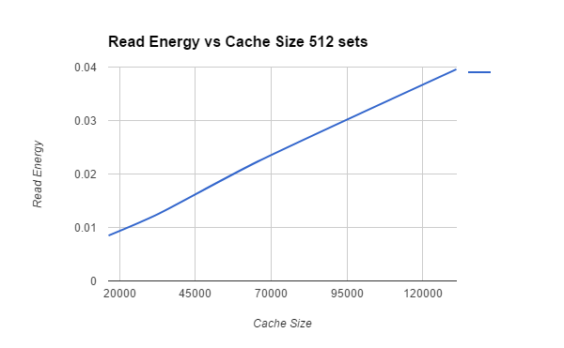

Access Time (ns)

|  |  |  |  |  |
| --- | --- | --- | --- | --- |
| #Set\Associativity | 1-way | 2-way | 4-way | 8-way |
| 128 sets | 0.135298 | 0.172884 | 0.209787 | 0.286515 |
| 256 sets | 0.15628 | 0.191458 | 0.232737 | 0.309199 |
| 512 sets | 0.182657 | 0.214102 | 0.260045 | 0.33468 |
| 1042 sets | 0.203715 | 0.25381 | 0.30401 | 0.380825 |

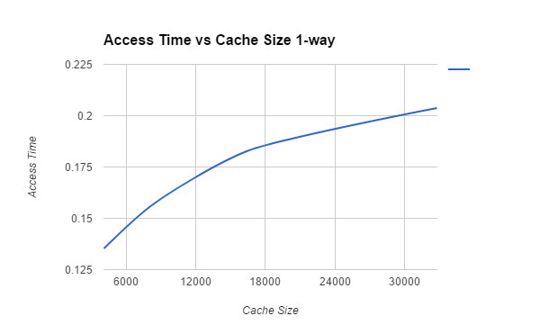

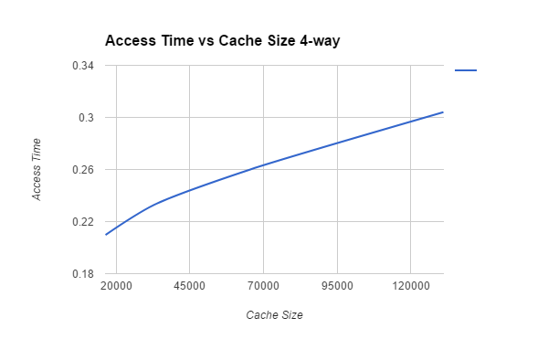

**Part 4.**

dl1 252785 misses = m1 tm = 100

dl2 7666 misses = m2 t1 = 1, t2 = 4

% gain = 0.92 = 92%

**Part 5.**

LRU : 0.0061

f 0.0062

r 0.0079